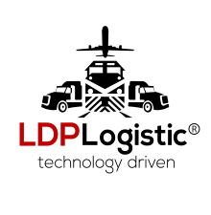
LDP LOGISTICS INC.
602 Hartle Street
Sayreville, NJ 08872
Tel : (732) 218-9958
Fax: 410-630-7250

PREPAY eCHECK AUTHORIZATION FORM

I hereby authorize LDP Logistics to process my stated eCheck information for each shipment made on my behalf by LDP logistics.

Type of Account: Checking Savings

Name on Account: _________________________________________________________________

Bank Account Number: ______________________________________________________________

Routing Number: ________________________________________________________________

Account Address: (where you receive your statements every month):

Street: ____________________________________________________

City: ______________________ State/Zip/Country: ____________ ___________ ________

Phone number: _____ _____________Email address: ______________________________

I agree that I will not dispute the above eCheck charge. I further understand that I cannot dispute this charge as a result of a freight claim for any reason. Any freight claim for damage, shortage or service failure must result in a freight claim with carrier, and refunds will be processed from the payout of the freight claim. I acknowledge the LDP Logistics Terms and Conditions as stated on their www.LDPlogistic.com/terms-and-conditions/ Quote amount is based upon the information provided by the customer. I also authorize LDP Logistics to process my stated eCheck information to cover any additional charges incurred by 3rd party as a result of information provided by the customer deemed to be inaccurate. If the echeck is returned for non-sufficient funds(NSF), the shipment can be stopped.

Signature: _________________________________ Date: ________________________

For Internal Use (if more than one invoice/BOL, use supplemental page):

Customer Acct#___________________ Customer Acct Name:____________________

BOL/Invoice # ____ Pmt #(if refund)____________

